Back ground Column chart is used to show severity levels as per the input data

It has lot of options to customize the is chart as per our needs.

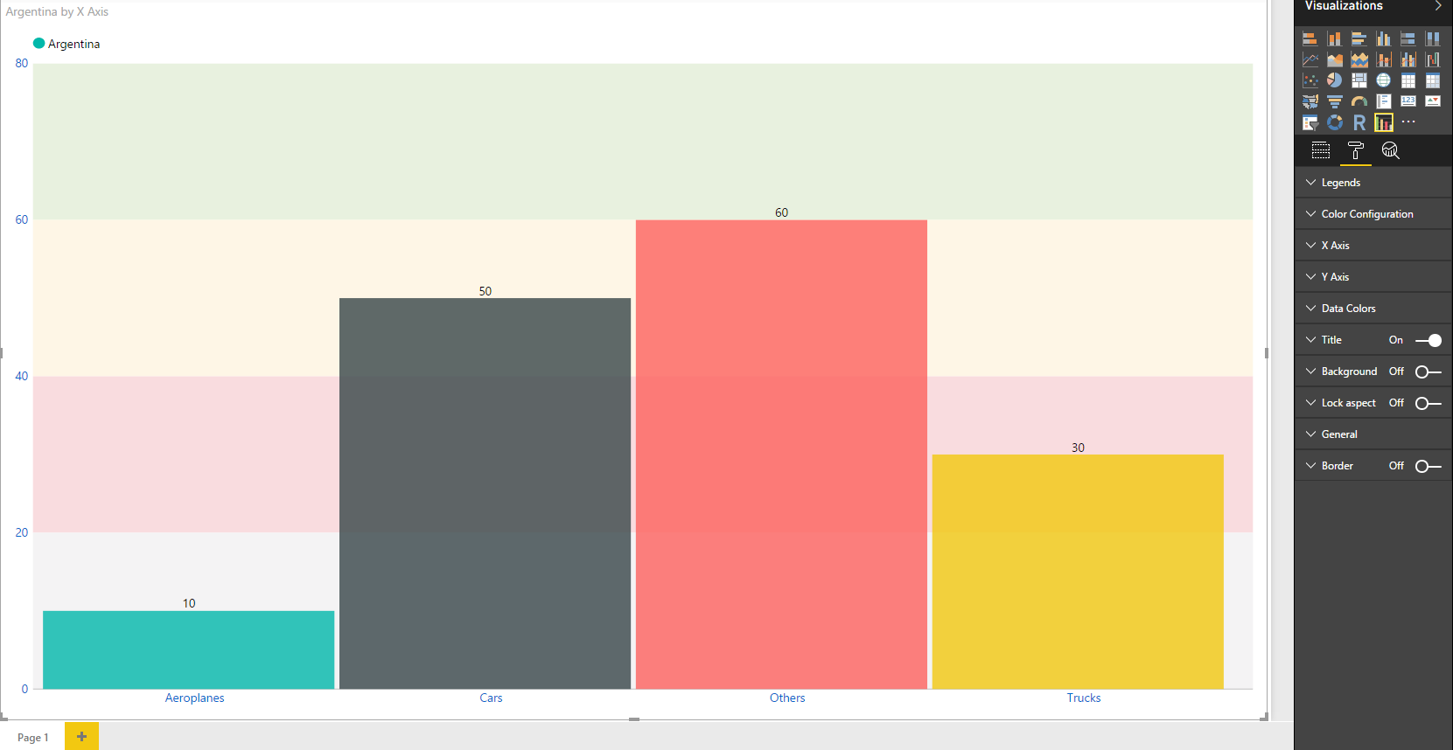

Configurations:

1. Legends:
   1. Enable: To enable legends
2. Color Configurations: To set colors of respective ranges
3. X Axis:
   1. Enable Labels: To show/hide labels on X Axis
   2. Font Size: To set font size of X Axis labels
4. Y Axis:
   1. Enable Labels: To show/hide labels on Y Axis
   2. Font Size: To set font size of Y Axis labels
   3. Enable Value Box Labels: To enable value box with respect to Y Axis
   4. Value Box Font Size: To set font size of value box
   5. Value Box Color: To set colors for Value Box
5. Data Colors: To set colors for columns